s****

M.V.P.SAMAJ’S

K.R.T ARTS, A.M.SCIENCE AND B.H.COMMERCE

COLLEGE, GANGAPUR ROAD

NASHIK.

**Online Tiffin Service**

**Developed by**

Dhikale Pratik Sudam[49]

Duddu vinay Adithya [51]

B.Sc. (Computer Science)

(2023-2024)

Under the guidance of

Professor S.S.PATIL

Department of Computer Science



M.V.P.SAMAJ’S

K.R.T ARTS, A.M.SCIENCE AND B.H.COMMERCE

COLLEGE, GANGAPUR ROAD

NASHIK.

**CERTIFICATE**

*This is to certify that project report on*

*Online Tiffin Service*

*Has been successfully completed by,*

Dhikale Pratik Sudam

Duddu vinay Adithya

*For fulfillment of T.Y.B.Sc (Computer Science)*

*During the academic year 2023-2024*

*(Project Guide) (Head of Department) (ExternalExaminer)*

Acknowledgement

We are happy to present the project *“**Online Tiffin Service*

*”* In PHP.

A Project titled *“Online Tiffin Service*” would not have been completed without the valuable guidance and encouragement of “Guide Name” and all staff members. We acknowledge them for their moral support.

This project is substantially upgrading our skill of software development which we intend to good use in developing better system in future.

In conclusion, we would like to express our thanks to management for providing us all facilities for completion of our project.

Finally we extend our thanks our all B.Sc. (Computer Science) staff, Classmates and also thanks to our parents to help us all time.

And special thanks to my Friends who helped us for successful completion of this project. They pointed out errors &suggested changes, thus helped in many ways, give us the idea of this project.

Dhikale Pratik Sudam

Duddu vinay Adithya

INDEX

|  |  |  |
| --- | --- | --- |
| **Sr.No** | **Title** | **Page NO.** |
|  | Introduction |  |
|  | Problem Definition. |  |
|  | Need of System |  |
|  | Proposed System |  |
|  | Feasibility study. |  |
|  | H/w and s/w requirement |  |
|  | ERD. |  |
|  | UML Diagrams. |  |
|  | Data Dictionary. |  |
|  | Sample I/O Screen. |  |
|  | Conclusion |  |
|  | Advantages |  |
|  | Bibliography |  |

Introduction

In the fast-paced world we live in, where time is a precious commodity, and lifestyles are increasingly hectic, the need for convenient and wholesome meal options has never been more critical. Enter "Online Tiffin Service," our revolutionary project aimed at simplifying the way individuals access quality and delicious meals in the comfort of their homes, especially tailored for those who have recently shifted to a new city.

**Understanding the Need:**

Moving to a new city is an exhilarating experience, but it often comes with its share of challenges. One significant concern for many is ensuring a steady and nutritious food supply. "Online Tiffin Service" is our response to this challenge, providing a reliable solution for individuals seeking a hassle-free way to enjoy home-cooked meals without the stress of cooking or compromising on taste.

**Our Vision:**

Our project envisions a world where everyone, irrespective of their location or busy schedules, can savor a variety of delectable meals at their convenience. We believe that good food should be accessible to all, and our online tiffin service is designed to bring culinary delight to your doorstep.

**Key Features:**

User-Friendly Interface: Navigating our platform is a breeze. With a user-friendly interface, our website ensures a seamless and intuitive ordering process. Whether you're a tech-savvy individual or someone new to online platforms, our design caters to all.

Customization Options: We understand that personal preferences and dietary restrictions vary. Our platform allows users to customize their tiffin orders, ensuring that every meal aligns perfectly with individual tastes and requirements.

Secure and Convenient Payment: Your security is our priority. Our platform features a secure payment gateway, providing multiple payment options for your convenience. Enjoy a hassle-free transaction experience every time.

**Why "Online Tiffin Service"?**

Home-Cooked Goodness: Our meals are crafted with care, mirroring the warmth and taste of home-cooked food. Each dish is prepared using high-quality ingredients to guarantee a delightful dining experience.

Timely Deliveries: Recognizing the value of your time, we have perfected a delivery system that is prompt and reliable. Your tiffin will reach you precisely when you expect it, allowing you to focus on your daily activities without worrying about your next meal.

Affordability: We believe in offering quality at a reasonable price. Our pricing model is competitive, ensuring that good, nutritious meals remain accessible to everyone.

Feedback-Driven Improvement: Your satisfaction is paramount to us. We actively encourage and appreciate your feedback, using it to continuously enhance our services and adapt to your evolving preferences.

Problem definition

***Problem Statement:***

In the fast-paced urban lifestyle, individuals, especially those who have recently shifted to a new city, often face the challenge of ensuring consistent access to home-cooked, nutritious meals. The existing options for meal solutions are either time-consuming, lack variety, or compromise on quality. The absence of a reliable, convenient, and customizable tiffin service creates a gap in meeting the dietary needs of individuals who are seeking a wholesome dining experience without the hassle of cooking.

Additionally, the busy schedules of students, professionals, and those adapting to a new environment make it challenging to prepare and enjoy homemade meals regularly. This leads to a reliance on fast food or unhealthy alternatives, negatively impacting health and overall well-being.

The problem lies in the absence of a dedicated and efficient online tiffin service that not only offers a diverse menu but also allows users to customize their meals according to their preferences. Furthermore, the lack of a secure and user-friendly platform for placing orders, coupled with unreliable delivery services, contributes to the overall inconvenience faced by individuals in search of a convenient and consistent meal solution.

In response to these challenges, our project, "Online Tiffin Service," aims to bridge this gap by providing a seamless online platform that offers a variety of home-style meals, customizable options, secure transactions, and timely deliveries. Our goal is to simplify the process of accessing quality, nutritious food for individuals in the new city environment, offering a solution that aligns with their tastes, preferences, and busy schedules

Need of system

1. Time-Efficiency:

- Need: Busy individuals seek a quick, hassle-free solution for nutritious

meals.

- Solution: "Online Tiffin Service" provides a time-efficient way to access quality meals.

2. Convenience for New Residents:

- Need: Newcomers to a city need a reliable source for home-cooked

meals.

- Solution: The service caters to new residents, offering a dependable food option.

3. Dietary Customization:

- Need: People want meals tailored to their dietary preferences.

- Solution: "Online Tiffin Service" offers customizable menus for a personalized dining experience.

4. Health and Well-being:

- Need: Individuals prioritize healthier eating habits.

- Solution: The service focuses on balanced, nourishing meals to promote well-being.

5. Variety and Menu Options:

- Need: Users seek a diverse range of meal choices.

- Solution: "Online Tiffin Service" provides a varied menu for different tastes.

6. Reliable Food Source:

- Need: People look for a consistent supply of quality meals.

- Solution: The service is a reliable platform for regular access to home-style meals.

7.User-Friendly Experience:

- Need: Consumers prefer an easy-to-use platform.

- Solution: "Online Tiffin Service" ensures a simple, user-friendly interface.

8. Affordability:

- Need: Individuals want cost-effective meal options.

- Solution: The service maintains competitive pricing for accessibility.

9.Timely Deliveries:

- Need: Punctuality is crucial for meal deliveries.

- Solution: The service prioritizes timely deliveries for user convenience.

10. Feedback Mechanism:

- Need: Users appreciate platforms that value their feedback.

- Solution: "Online Tiffin Service" welcomes user feedback for continuous improvement.

Proposed System

"Online Tiffin Service" offers a swift, user-friendly solution for quality meals. Ideal for busy individuals and new city residents, it provides customizable, nutritious options, ensuring a reliable and timely delivery service. With competitive pricing and a feedback-friendly approach, it's the go-to platform for a diverse menu of home-style meals.

Feasibility Study

1. Technical Feasibility:

- Assessing the technical requirements and capabilities needed for the successful implementation of a new software system.

2. Economic Feasibility:

- Analyzing the cost-effectiveness and financial viability of introducing automated machinery to streamline manufacturing processes.

3. Operational Feasibility:

- Evaluating how the implementation of a new inventory management system aligns with current operational processes, including employee training and workflow adjustments.

4. Technical and Operational Feasibility:

- Investigating the feasibility of integrating a new customer relationship management (CRM) software into existing operational structures to enhance customer service and efficiency.

5.Economic and Operational Feasibility:

- Assessing the financial impact and operational benefits of adopting renewable energy sources within a manufacturing facility.

6.Technical and Economic Feasibility:

- Analyzing the technical requirements and economic implications of transitioning from a traditional payment system to blockchain technology in a financial institution.

These topics allow for a focused exploration of technical, economic, and operational aspects individually or in combination, providing a well-rounded understanding of the feasibility of a proposed project or initiative.

Hardware Software Requirements

Hardware Requirements:

* i3 Processor
* 8 GB RAM
* 500 GB HARDDISK

Software Requirements

* OPERATING SYSTEM: Windows
* LANGUAGE: HTML, CSS, PHP
* FRONTEND: HTML,CSS,PHP
* BACKEND: MYSQL,PHP,JAVA

ER DIAGRAM

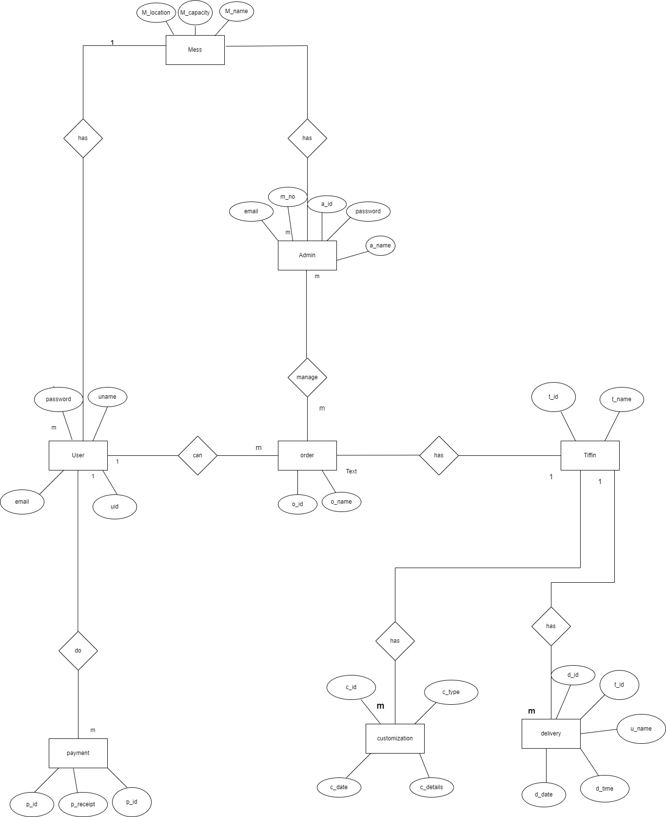

USE CASE DIAGRAM

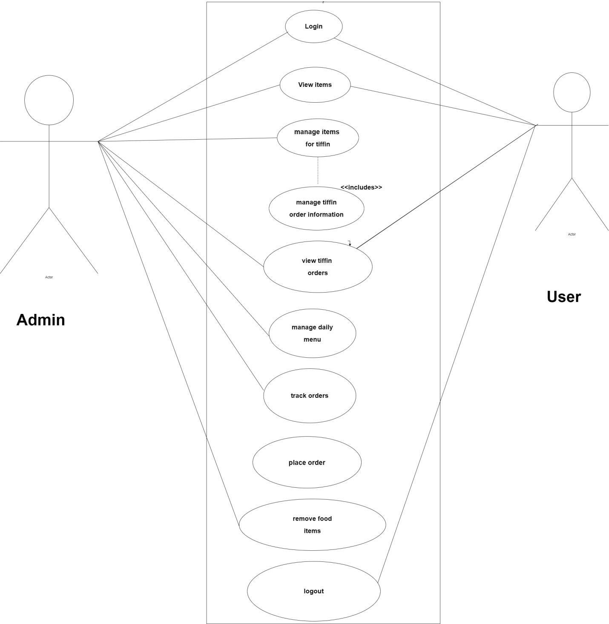

SEQUENCE DIAGRAM

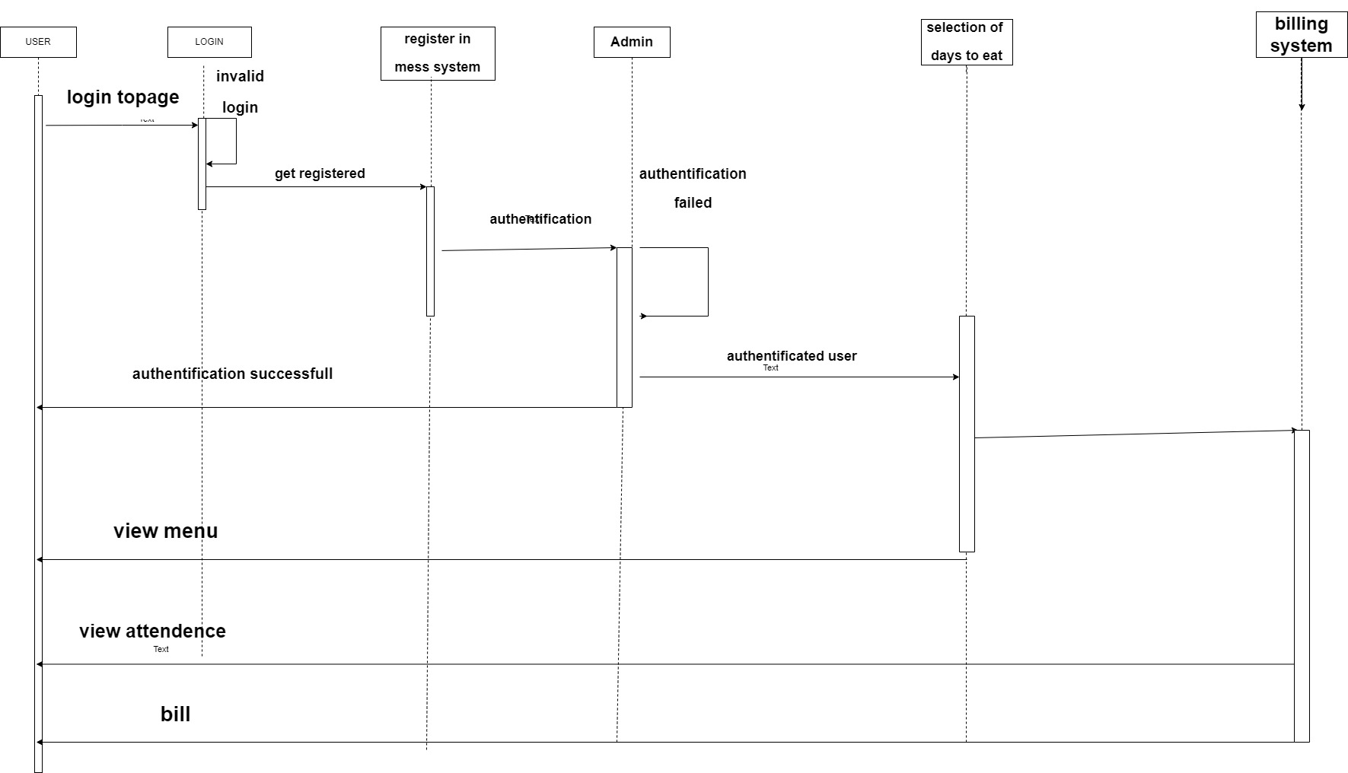

ACTIVITY DIAGRAM

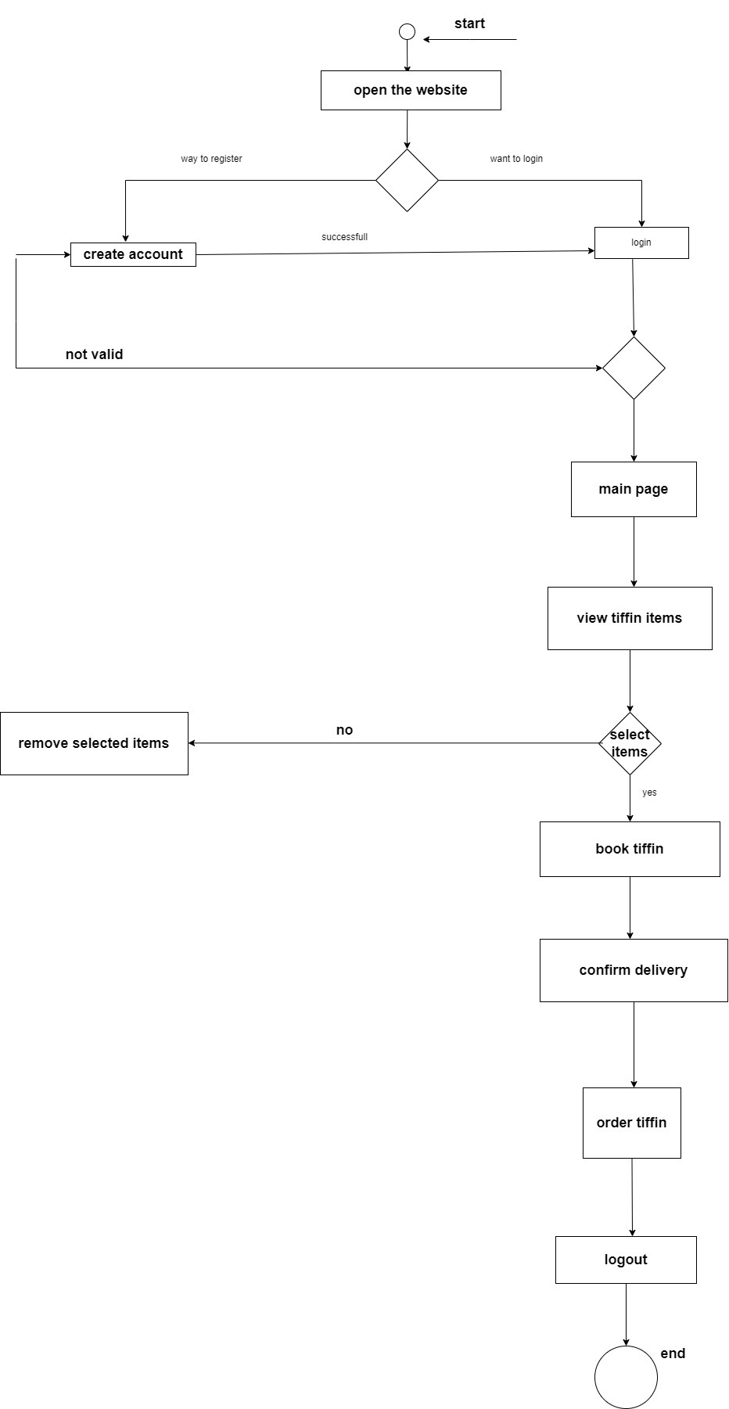

CLASS DIAGRAM

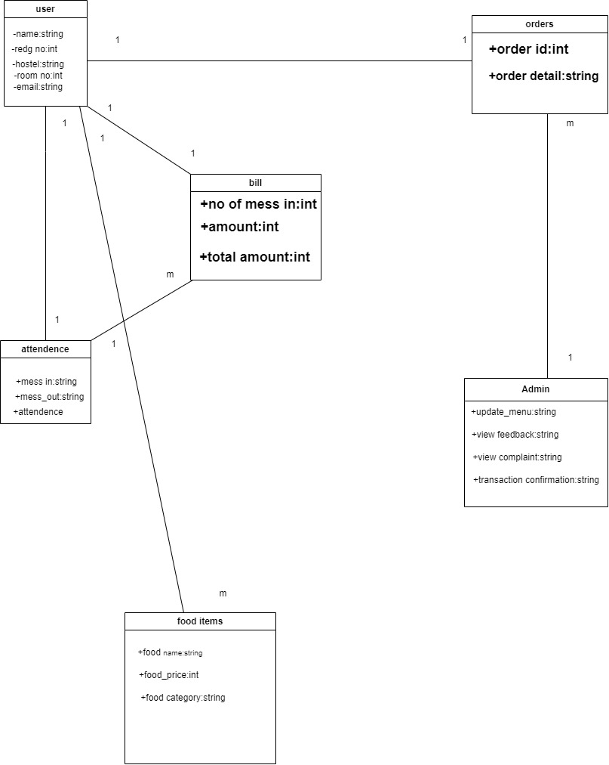

COMPONENT DIAGRAM

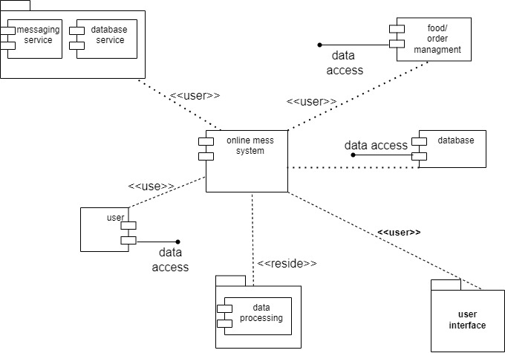

DEYPLOYMENT DIAGRAM

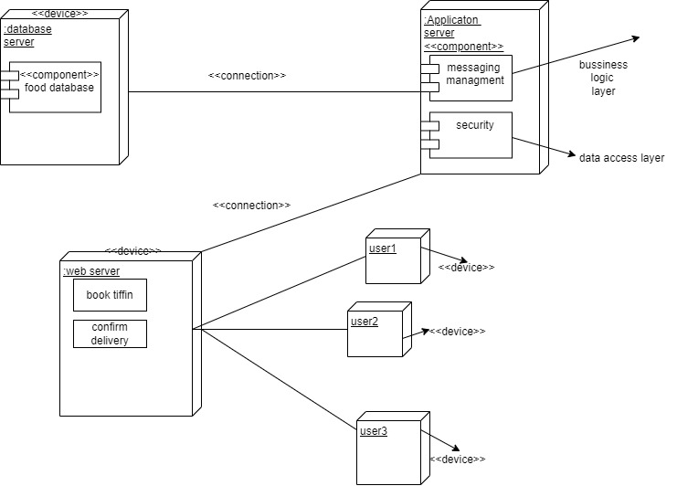

DATA DICTIONARY

1)ORDERS:

|  |  |  |  |
| --- | --- | --- | --- |
| Names | Type | Null | Default |
| Id | Int(11) | No | None |
| Name | Varhar(255) | No | None |
| Mobile no | Varchar(15) | No | None |
| Preferred_time | Varchar(20) | No | None |
| Start_date | date | No | None |
| End_date | Date | No | None |
| Address | Text | No | None |
| Tiffin_id | Int(11) | yes | NULL |

2)TIFFIN

|  |  |  |  |
| --- | --- | --- | --- |
| Names | Type | Null | Default |
| Tiffin_id | Int(11) | No | None |
| Tiffin_name | Varchar(255) | No | None |
| Tiffin_description | Text | No | None |
| Tiffin_image | Varchar(255) | No | None |
| Tiffin_price | Decimal(10,2) | No | None |
| Tiffin_style | Varchar(255) | No | None |

3)TIFFIN_ITEMS:

|  |  |  |  |
| --- | --- | --- | --- |
| Names | Type | Null | Default |
| Tiffin_id | Int(11) | No | None |
| Tiffin_id | Int(11) | Yes | NULL |
| Tiffin_name | Varchar(255) | No | None |
| Tiffin_quantity | Int(11) | No | None |

4)TIFFIN_PRICES:

|  |  |  |  |
| --- | --- | --- | --- |
| Names | Type | Null | Default |
| Price_id | Int(11) | No | None |
| Tiffin_id | Int(11) | Yes | NULL |
| price | Decimal(10,2) | No | No |

5)USERS:

|  |  |  |  |
| --- | --- | --- | --- |
| Name | Type | Null | None |
| Id | Int(11) | No | None |
| First name | Varchar(50) | No | None |
| Last name | Varchar(50) | No | None |
| User name | Varchar(50) | No | None |
| Email | Varchar(100) | No | None |
| Password | Varchar(255) | No | None |
| Avatar | Varchar(100) | No | None |
| It_admin | Tinyint(1) | No | None |

CONCLUSION:

In the fast-paced landscape of modern living, where time is a precious commodity, "Online Tiffin Service" stands as a testament to the fusion of technology and culinary artistry. As we conclude this project, we reflect on the journey of conceptualization, development, and the realization of a solution that not only meets but exceeds the expectations of individuals seeking a convenient, wholesome dining experience.

From the outset, the primary objective was clear: to bridge the gap between busy schedules, diverse tastes, and the universal need for nourishing meals. Through meticulous planning and agile development, "Online Tiffin Service" has emerged as a seamless online platform, offering a diverse menu, customizable options, and secure transactions, all wrapped in the warmth of home-cooked goodness.

The technical feasibility of our system has been meticulously crafted, ensuring a user-friendly interface, robust security features, and scalability for future enhancements. Economic feasibility is evident in the competitive pricing model that democratizes access to quality meals. Operationally, the system integrates seamlessly into the daily lives of users, simplifying the entire process from ordering to timely deliveries.

As we envisage the impact of "Online Tiffin Service" on individuals, especially those navigating new cities or navigating hectic schedules, we see more than a project; we see a culinary companion, a solution to the perpetual challenge of balancing time constraints with the desire for nutritious, personalized meals.

The journey doesn't end here. With an open door for user feedback, "Online Tiffin Service" is ready to evolve. The constant refinement and adaptation to user needs will propel this project beyond a static solution, making it a dynamic force in the realm of online culinary services.

In conclusion, "Online Tiffin Service" is not just a project; it's a commitment to enhancing the daily lives of our users, one delightful meal at a time. As the aroma of success lingers, we look forward to the continued growth, positive impact, and the joy our platform brings to the tables of individuals seeking culinary satisfaction in the midst of their busy lives.

ADVANTAGES:

1. Convenience:

- Advantage: Users can enjoy the convenience of ordering home-style meals with just a few clicks, eliminating the need for time-consuming meal preparation.

2. Customization:

- Advantage: The platform offers meal customization, allowing users to tailor their orders according to their tastes, dietary preferences, and nutritional requirements.

3. Time-Efficiency:

- Advantage: Busy individuals, including those who have recently shifted to a new city, benefit from the time-efficient solution, ensuring they have access to quality meals without compromising on time.

4. Diverse Menu:

- Advantage: A varied menu caters to different culinary preferences, providing users with a range of options to choose from and preventing meal monotony.

5. Affordability:

- Advantage: Competitive pricing makes quality meals accessible to a broad audience, ensuring that affordability is not a barrier to enjoying nutritious and delicious food.

6. User-Friendly Interface:

- Advantage: The user-friendly interface simplifies the ordering process, making it accessible to individuals of all technological backgrounds.

7. Secure Transactions:

- Advantage: The platform prioritizes security, providing users with a safe and secure payment gateway for hassle-free transactions.

8. Reliable Delivery:

- Advantage: Timely and reliable deliveries ensure that users receive their meals when expected, accommodating their busy schedules and commitments.

9. Adaptability:

- Advantage: The system is adaptable, with an openness to user feedback, allowing for continuous improvement and the incorporation of new features based on evolving user needs.

10. Health and Well-being:

- Advantage: By focusing on providing nutritious and balanced meals, the platform promotes a healthier lifestyle for users who prioritize their well-being.

11. Culinary Exploration

- Advantage: Users have the opportunity to explore a variety of cuisines and flavors, broadening their culinary experiences from the comfort of their homes.

12. Community Engagement:

- Advantage: "Online Tiffin Service" fosters a sense of community by connecting users with local chefs and culinary artisans, creating a platform for culinary enthusiasts to showcase their skills.

13. Sustainability:

- Advantage: By offering a sustainable alternative to fast food and single-use packaging, the project aligns with environmental consciousness and promotes eco-friendly dining choices.

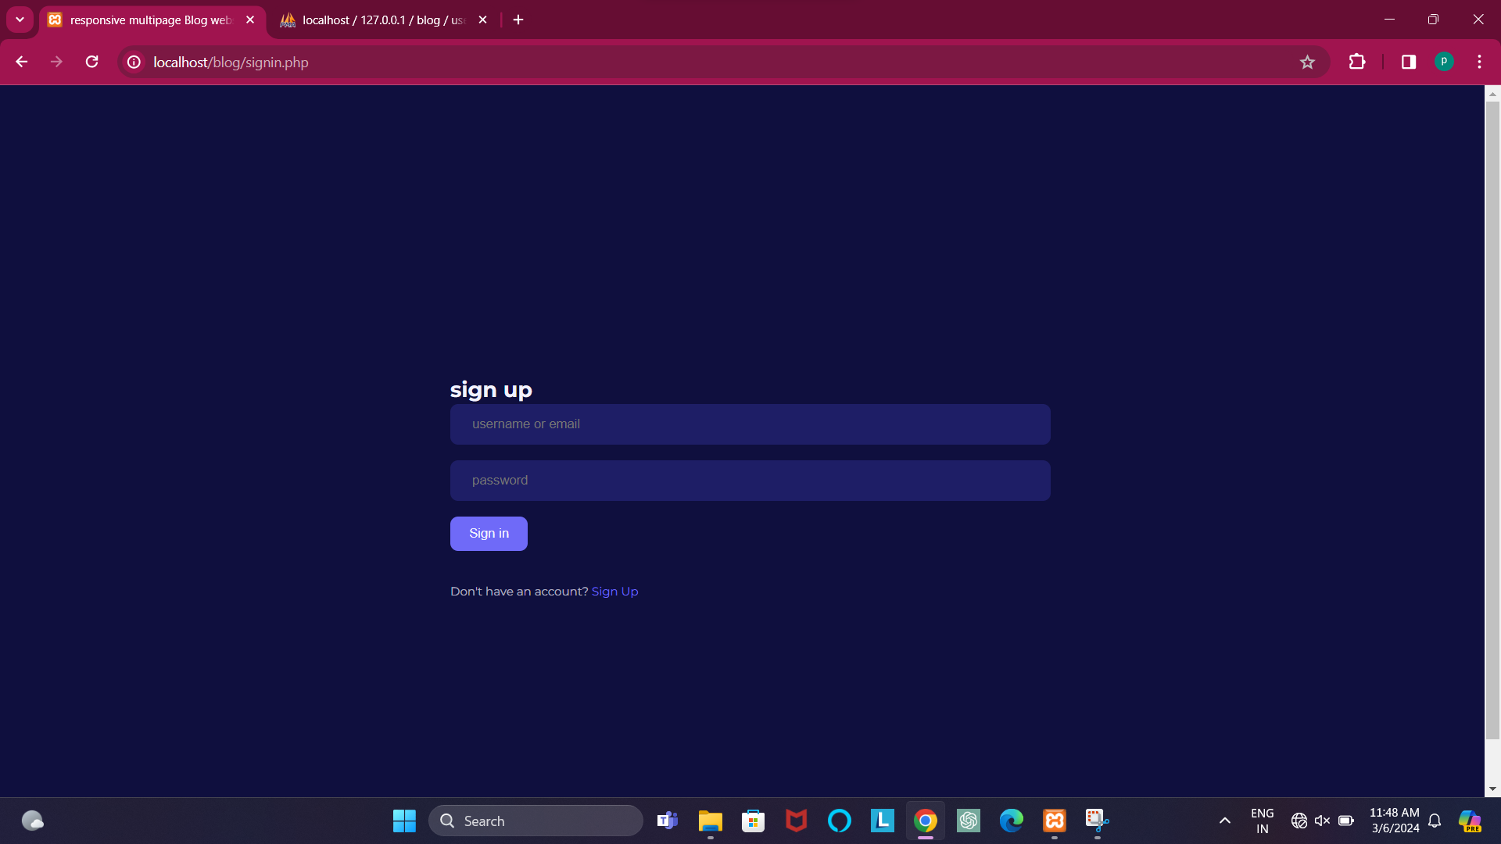

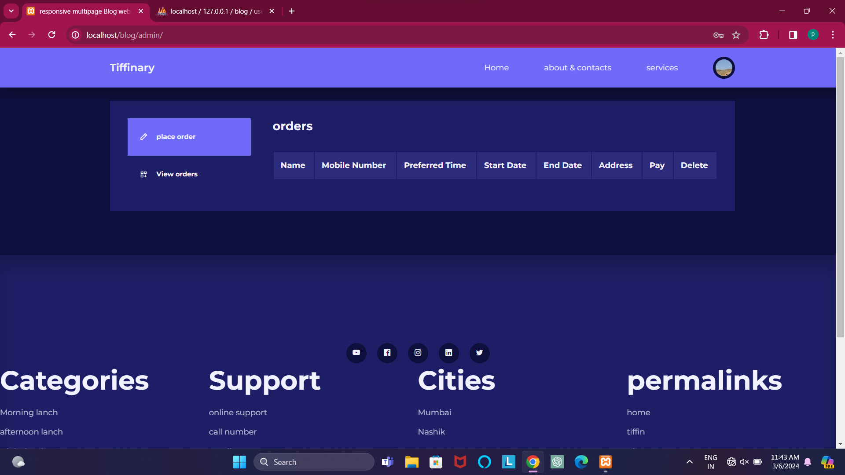

USER PAGE

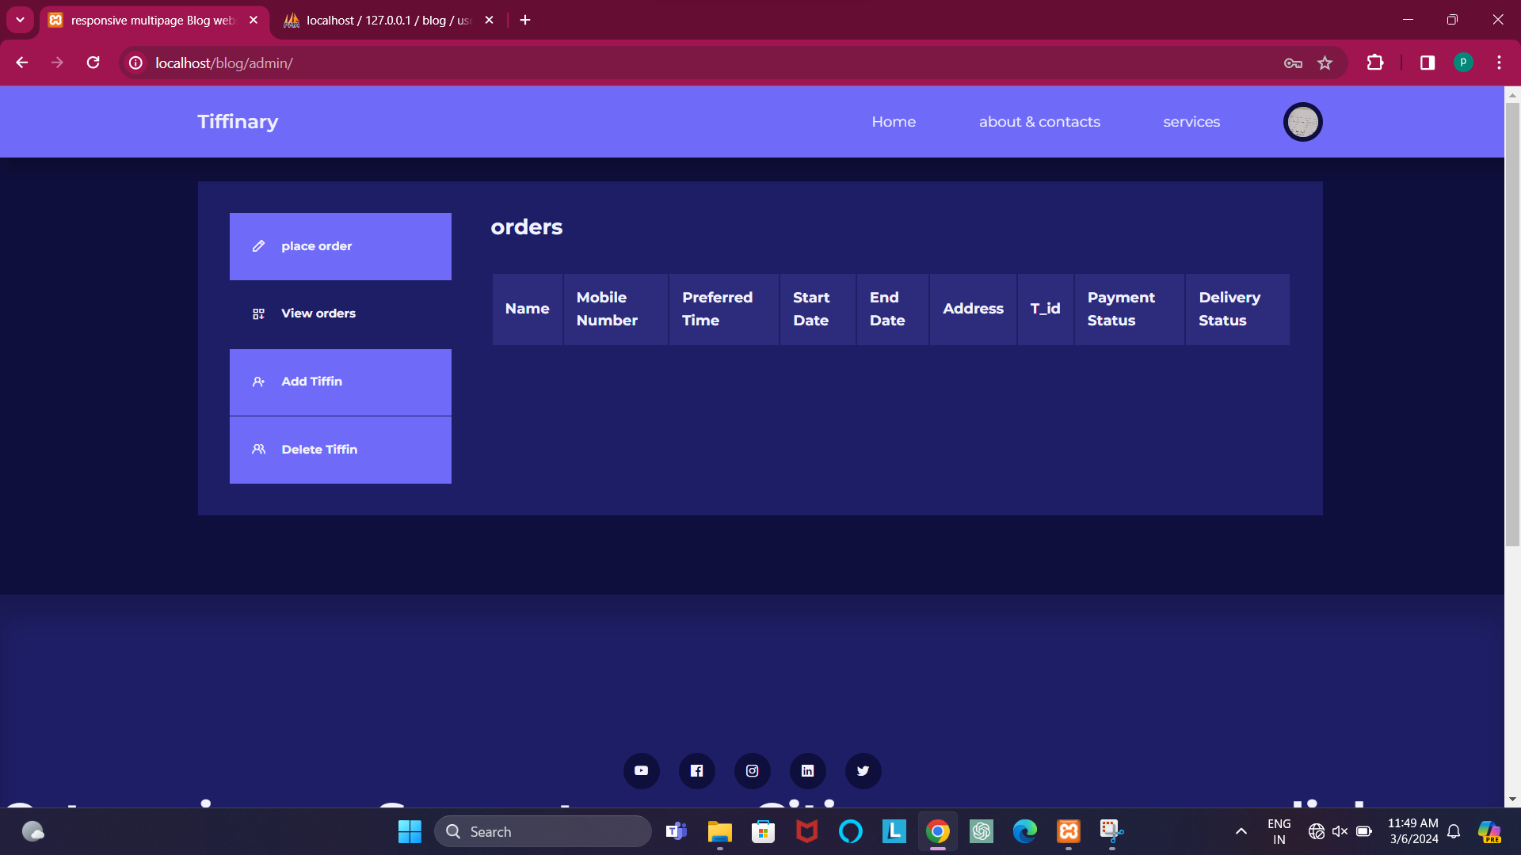

ADMIN PAGE

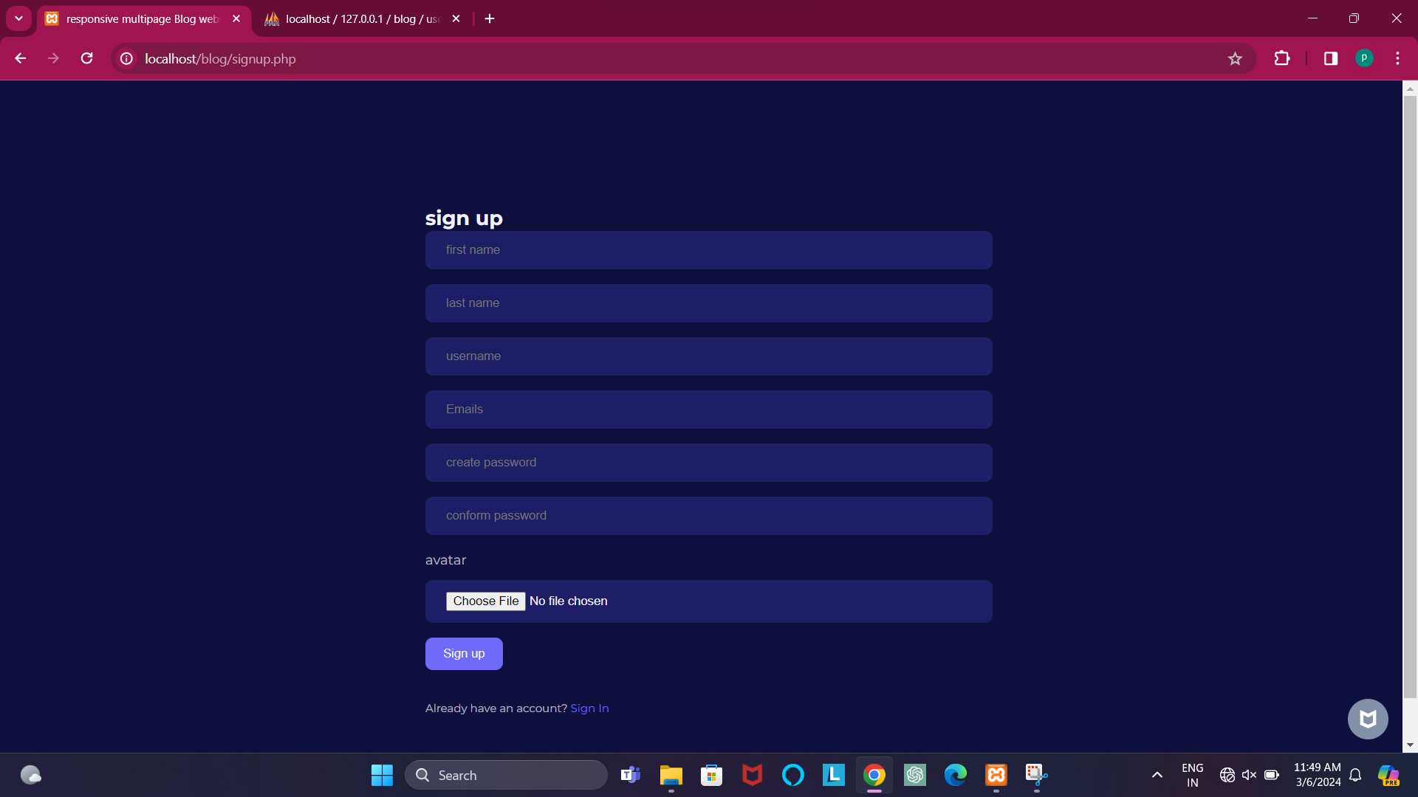

SIGN UP PAGE

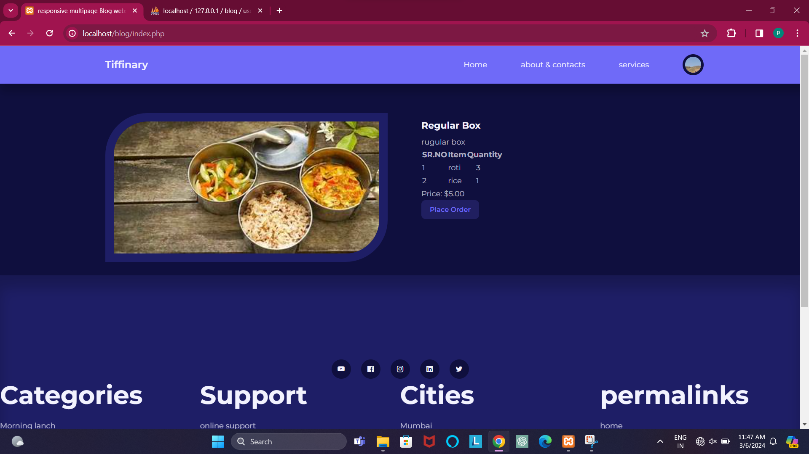

HOME PAGE

Bibliography



1. Learning PHP, MySQL & JavaScript
2. PHP for the Web
3. http://www.wikepedia.com